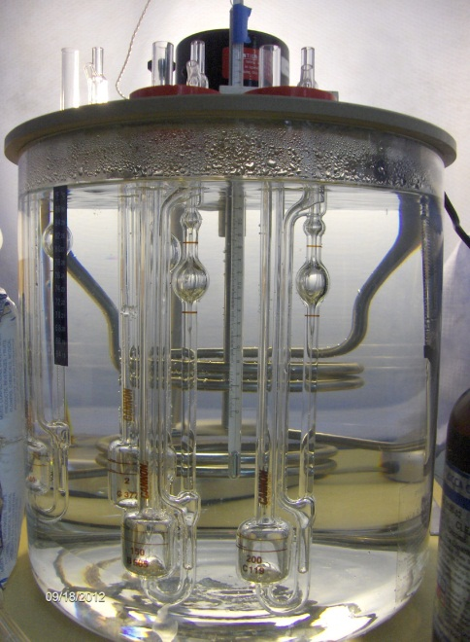
Dilute Solution Viscosity Analysis

Associated Polymer Labs has the expertise to measure the dilute solution viscosity of your polymer, plastic, oil, or lubricant. We use several types of viscometers that include: Cannon Fenske, Cannon Ubbelohde, and Ubbelohde. Every viscometer has a certificate of calibration.

Dilute Solution Viscosity is the viscosity measurement of dilute solutions of polymers. Normally a polymer or plastic is dissolved in a solvent (ASTM D5226) at a specified concentration in the range 0.2 – 1.0 g/dl (0.002-0.01 g/ml). Polymer solution viscosity is measured relative to the viscosity of the pure solvent.

The Table below summarizes the test methods
Method Number | Description
ASTM D2857 | Standard Practice for Dilute Solution Viscosity of Polymers
ISO 1628 | Plastics-Determination of Viscosity Number and Limiting Viscosity Number
ISO 307 | Specifies a method for the determination of the viscosity number of dilute solutions of polyamides in certain specified solvents
ASTM D5226 | Practice for Dissolving Polymer Materials
ASTM D4603 | Test Method for Determining Inherent Viscosity of Poly(Ethylene Terephthalate) (PET) by Glass Capillary Viscometer
ASTM D1243 | Test Method for Dilute Solution Viscosity of Vinyl Chloride Polymers

Background and Fundamentals of Viscosity
All polymers increase the viscosity of the solvent in which they are dissolved. This increase allows for a convenient method of determining the molecular weight of polymers. Since the viscosity method is not based on rigorous physical laws, it must be calibrated by standards of known molecular weight with narrow molecular weight distributions.
Several important viscosity functions are used in viscosity studies.
The relative viscosity, η_{r} = (η / η _{o} ) is the dimensionless ratio of solution viscosity, η, to solvent viscosity, η _{o}.
The specific viscosity, η _{sp} = (η - η _{o}) /η _{o} is related to the fluid viscosity increase due to all polymer solute molecules.
The reduced viscosity, η _{red} = η _{sp} /c is the fluid viscosity increase per unit of polymer solute concentration, c.
The intrinsic viscosity, [η] is the limit of the reduced viscosity as the polymer solute concentration approaches zero. The intrinsic viscosity is also the limit of the inherent viscosity, ln(η / η _{o}) as the solution polymer concentration approaches zero.
( η ) = lim η_{red} / conc = lim ln ( η / η◦ ) / conc
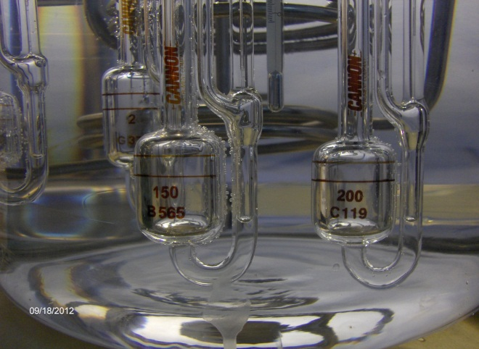
Extrapolation to zero polymer concentration is intended to eliminate polymer intermolecular interactions. When the polymer concentration is expressed in g/dl, the units of [η] will be dl/g. The plots used to find the intrinsic viscosity are called the Huggins plot ( η _{red} vs. c ) and the Kraemer plot ( ln(η / η_{o}) vs. c ).

Viscosity Number - ISO 307 provides a measure of the molecular mass of a polymer. ISO 307 deals with the determination of viscosity number for polyamide materials.
The polyamide material is dissolved in a solvent and the solution is poured into a viscometer. The viscometer is immersed in a constant temperature bath at 25°C. The time for the solution to flow between the two graduation lines is recorded. The test is repeated with the solvent and the time is recorded.
Solvents
Name | Chemical Symbol | Concentration
Formic Acid | HCOOH | 90%
m-Cresol | C₇H₈O | 99%
Sulfuric Acid | H₂SO₄ | 96%
Viscosity number is calculated using:
VN = (t/t_{o} - 1)/c
where t is the flow time of the solution in seconds,
t_{o} is the flow time of the solvent in seconds,
and c is the concentration of the polymer in g/ml of solution.
Associated Polymer Labs provides this service so you get answers to your dilute solution viscosity analysis fast, and save money. Contact us and discover how Associated Polymer Labs can help your organization using dilute solution viscosity measurements.

